A1344-Peru-South Coast-Tiahuanaco-Middle Horizon-Feline Designs-600-1000 CE

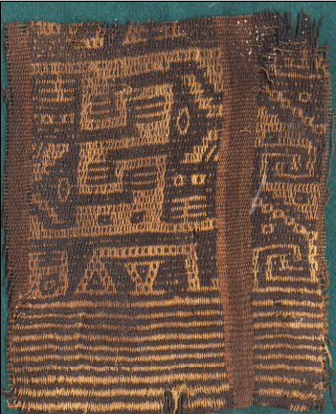 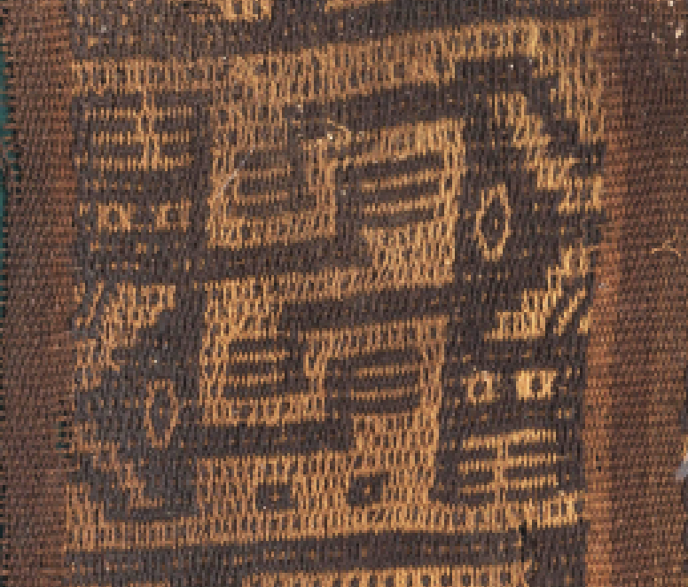

Figs. 1-2. Peru-South Coast-Tiahuanaco-Middle Horizon-Feline Designs-600-1000 CE

**Case no.: 7**

**Accession Number: A1344**

**Formal Label:** Peru-South Coast-Tiahuanaco-Middle Horizon-Feline Designs-600-1000 CE **Display Description:**

This abstract textile Tiahuanaco (Middle Horizon) panel encompasses designs composed of juxtaposed, interlocking feline bodies within a square compartment that was probably part of a large rectangular panel. This is one of the tightest hand-woven textiles ever made, belonging to the great masterpieces of world art in their technical composition and the boldness of their designs. The transfer of religious motifs from stone reliefs to textiles suggests a Highland origin where these stone monuments are located. The basic pattern for this textile art consists of highly abstract figures composed if many individual elements separated into cube-like forms which incorporates the iconographic techniques of the “Gateway to the Sun.”

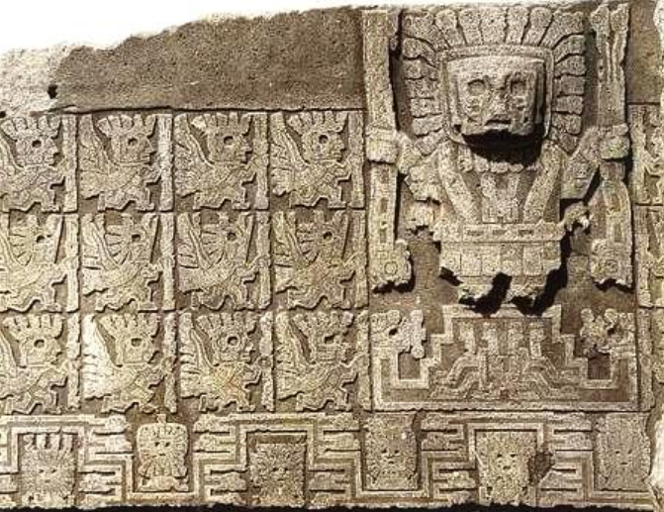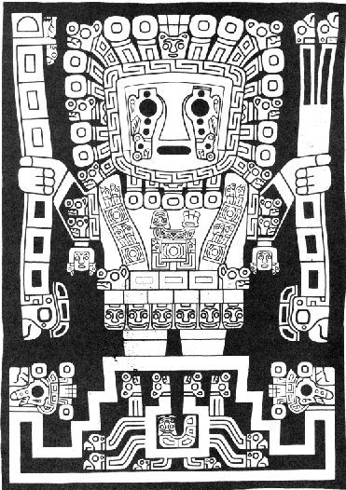

Fig. 3. Detail of the lintel of the “Gateway of the Sun.” From [http://web.archive.org/web/20160304055141/http://bilddatenbank.khm.at/viewArtefact?id=253875](http://web.archive.org/web/20160304055141/http:/bilddatenbank.khm.at/viewArtefact?id=253875)

Fig. 4. Detail of the lintel of the “Gateway of the Sun.” From Anton 1984: 103.

**LC Classification:** F3319.1.T55

**Date or Time Horizon:** 600-1000 CE

**Geographical Area:** Tiahuanaco, Bolivia.

**Map, GPS coordinates:** [16°33′17″S 68°40′24″W](https://tools.wmflabs.org/geohack/geohack.php?pagename=Tiwanaku&params=16_33_17_S_68_40_24_W_type:landmark)

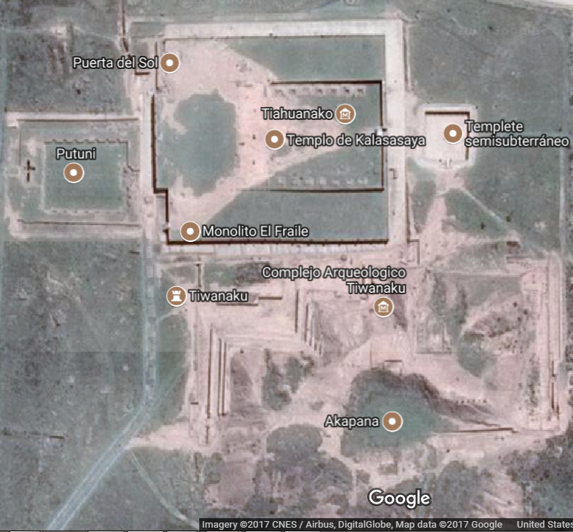

**Cultural Affiliation:** Tiahuanaco-Huari

**Media:** wool, vegetable dyes

**Dimensions:** various

**Weight: various**

**Condition: original**

**Provenance:** unknown

**Discussion:**

Tiahuanaco is near the shores of Lake Titicaca, the epicenter of a self-sustaining empire in 600 AD/CE with a total population about 365,000, of which 115,000 lived in the capital and satellite cities, with the remaining 250,000 engaged in farming, herding, and fishing. Its roots lie in a 400 BCE village under its civic-ceremonial core. The city of 40,000 evolved into a series of multi-terraced platform pyramids, courts and urban areas, covering 2.31 mi2 by 600 AD/CE. Food was provided by agricultural fields, llama herds on the Poona, and abundant fish from Lake Titicaca. The capital was surrounded by a moat that restricted access to the four multi-terraced platform pyramids of which the largest, the square Akapana, 656 ft2 and a height of 55.8 ft. had a base of cut and joined stone blocks. On its summit was a sunken court with an area 164 ft2 with a subterranean drainage system. Four pyramids: the Semi-subterranean, the Kalasasaya, the Putuni, and the Kheri Kala had sculptured stone heads set into cut-stone facing walls and in the middle of the court and a monolithic stela of a ruler wearing an elaborate regal costume and a crown. Gold plaques and textiles no longer adorn the walls of these pyramids.

**References:**

Anton, Ferdinand. 1984. *Ancient Peruvian Textiles*. London: Thames and Hudson.

Protzen, Jean-Pierre. 2013. *The stones of Tiahuanaco: a study of architecture and construction*. Los Angeles : Cotsen Institute of Archaeology Press, University of California, Los Angeles